

Experiment No.: 8
- Title: Access and validate form fields using events; design a gym admission form with live input checks.

- Software/Tools Required: Visual Studio Code (VS Code), web browser, HTML, JavaScript.

- Theory: Form validation in JavaScript is used to check whether the data entered by a user is correct and complete before submitting a form. JavaScript can access form fields using DOM methods such as getElementById() and respond to user actions using events like input, change, and submit. In a Gym Admission Form, live input validation can be used to check fields such as name, email, phone number, age, and membership type while the user is entering data. If the entered data is invalid, an error message can be displayed immediately using DOM manipulation. Regular expressions can also be used to validate formats such as email addresses and phone numbers. This makes the form more user-friendly and prevents incorrect data from being submitted.

Output :

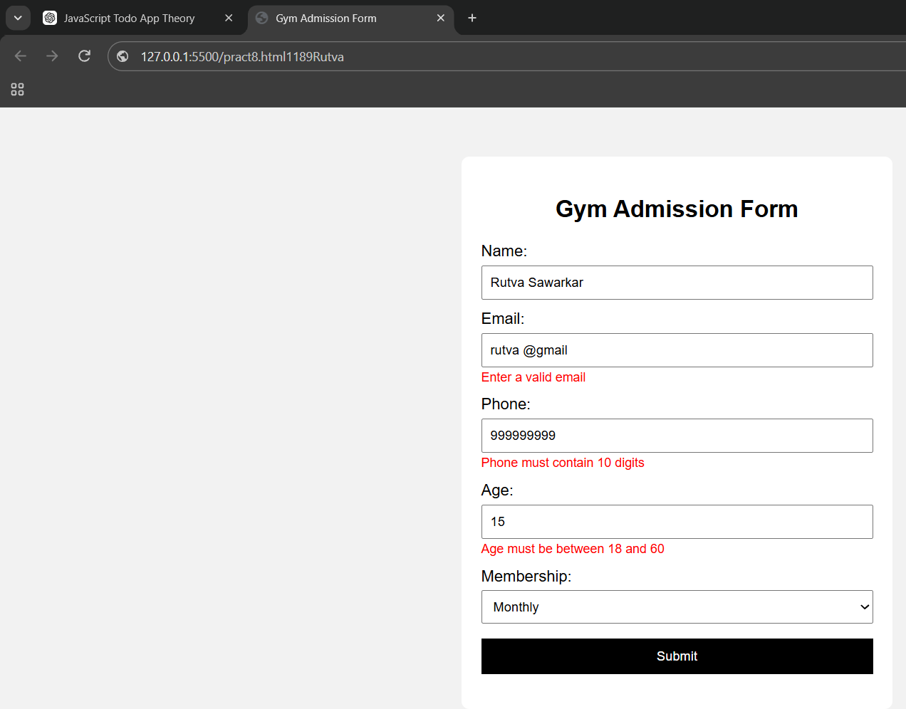
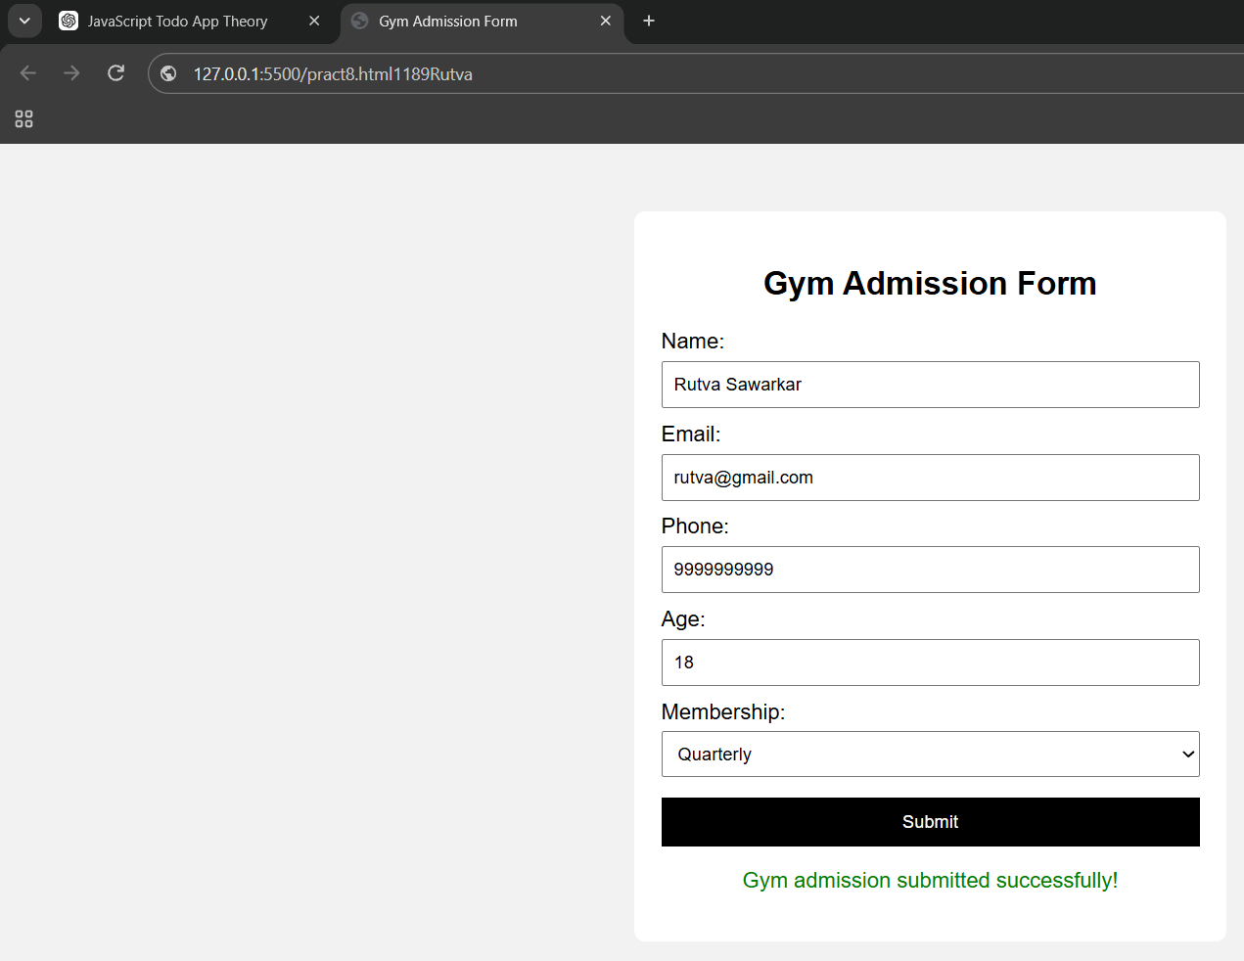

Conclusions: The Gym Admission Form successfully demonstrates how JavaScript events and DOM methods can be used to access and validate form fields. Live input checks provide immediate feedback to the user and ensure that valid information is submitted. This experiment helps in understanding event handling, form validation, DOM manipulation, and basic JavaScript interaction with HTML forms.

CASE STUDY 08

Case Study: Create an Online Job Application Form Using Javascript.
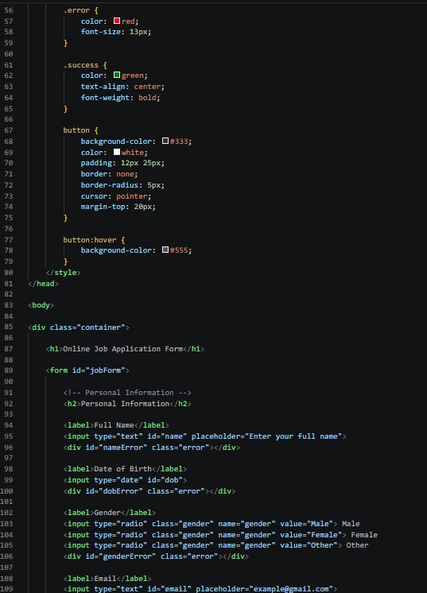
PROGRAM CODE:
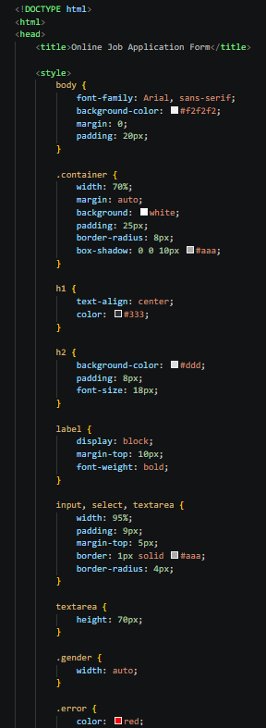

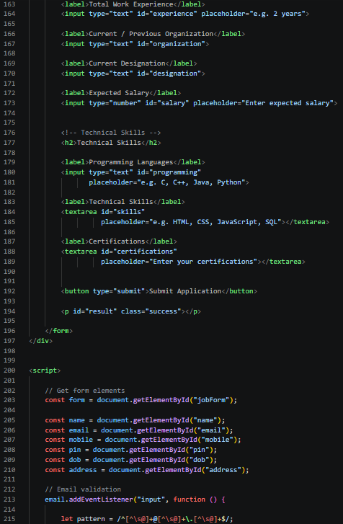
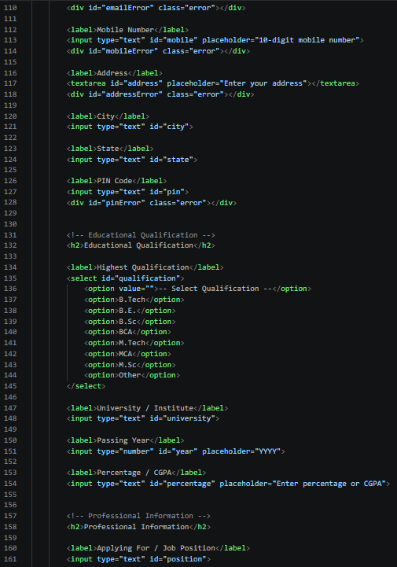

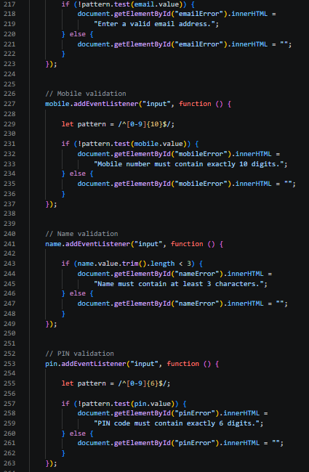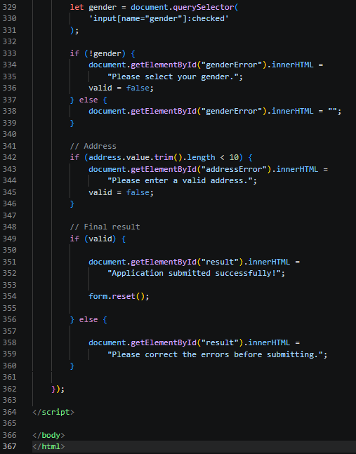
3. Output:
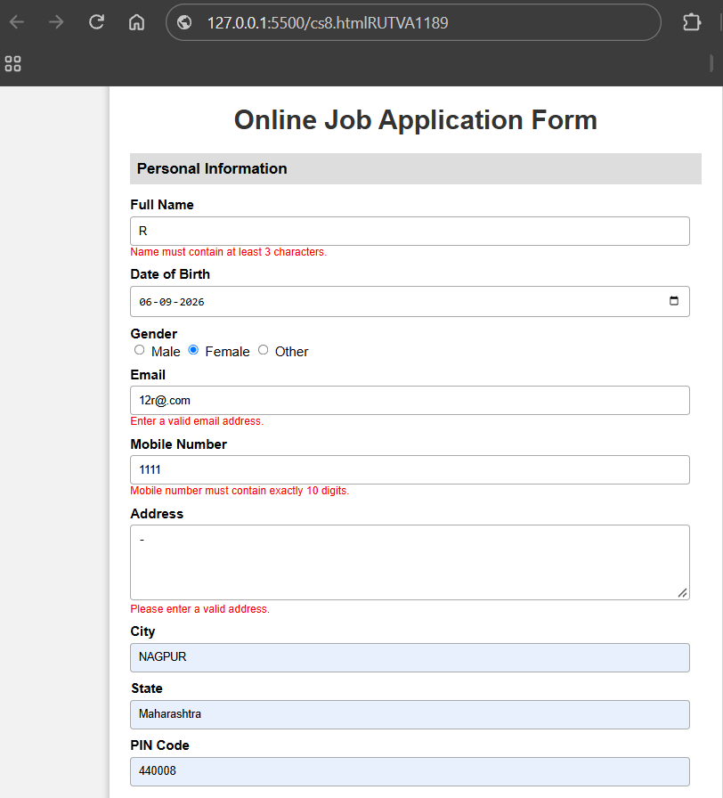


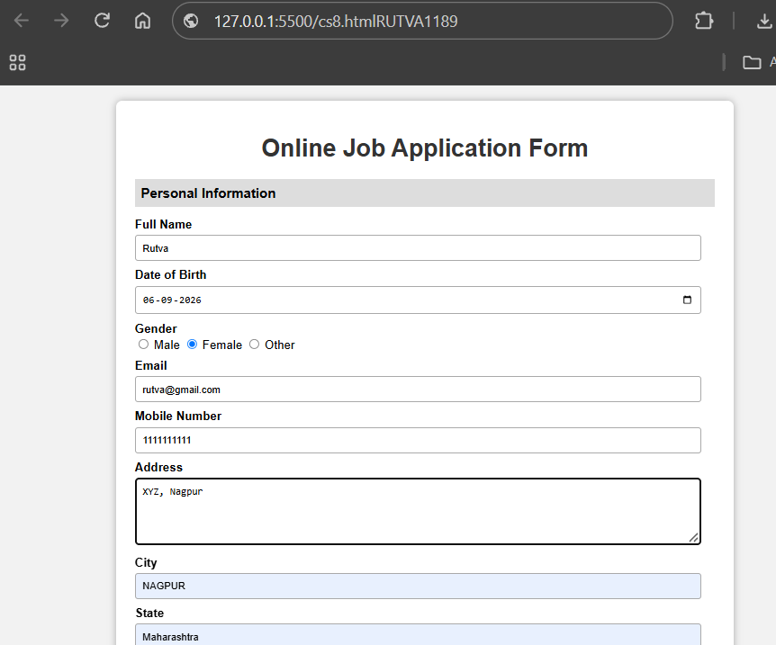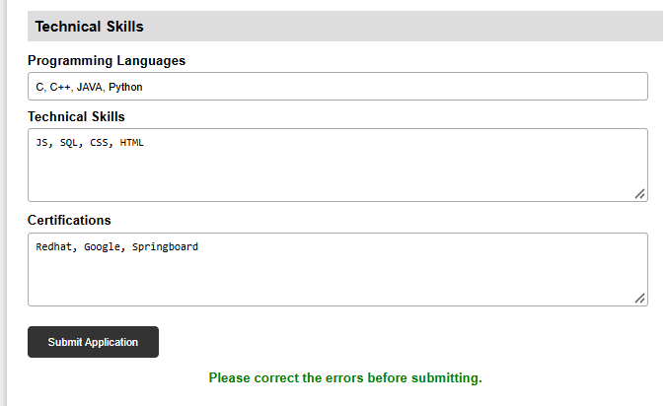
4. Result / Conclusion: The Online Job Application Form was successfully created using HTML, CSS, and JavaScript. JavaScript was used to validate the applicant’s personal, contact, and educational details before submission. The form checks whether the entered information is valid and displays appropriate messages for incorrect or missing details. Thus, the case study demonstrates how JavaScript can be used for form validation, error handling, and creating an interactive webbased application form.

